# TASK 1:

<!DOCTYPE html>

<html lang="en">

<head>

  <title>Bootstrap Page</title>

<meta charset="utf-8">

  <meta name="viewport" content="width=device-width, initial-scale=1">

  <link href="https://cdn.jsdelivr.net/npm/bootstrap@5.3.2/dist/css/bootstrap.min.css" rel="stylesheet">

  <script src="https://cdn.jsdelivr.net/npm/bootstrap@5.3.2/dist/js/bootstrap.bundle.min.js"></script>

</head>

<body>

  <div class="alert alert-success">

    <strong>Success!</strong> You should <a href="https://www.w3schools.com/bootstrap/bootstrap_ver.asp" class="alert-link" target="blank">read this message</a>.

  </div>

  <div class="alert alert-info">

    <strong>Success!</strong> You should <a href="https://www.w3schools.com/bootstrap/bootstrap_ver.asp" class="alert-link" target="blank">read this message</a>.

  </div>

  <div class="alert alert-warning">

    <strong>Success!</strong> You should <a href="https://www.w3schools.com/bootstrap/bootstrap_ver.asp" class="alert-link" target="blank">read this message</a>.

  </div>

  <div class="alert alert-warning">

    <strong>Success!</strong> You should <a href="https://www.w3schools.com/bootstrap/bootstrap_ver.asp" class="alert-link" target="blank">read this message</a>.

  </div>

  <div class="alert alert-danger">

    <strong>Success!</strong> You should <a href="https://www.w3schools.com/bootstrap/bootstrap_ver.asp" class="alert-link" target="blank">read this message</a>.

  </div>

  <div class="alert alert-danger">

    <strong>Success!</strong> You should <a href="https://www.w3schools.com/bootstrap/bootstrap_ver.asp" class="alert-link" target="blank">read this message</a>.

  </div>

<div class="container-fluid p-5 bg-primary text-white text-center">

  <h1>My First Bootstrap Page</h1>

  <p>Resize this responsive page to see the effect!</p>

</div>

</body>

</html>

# OUTPUT:

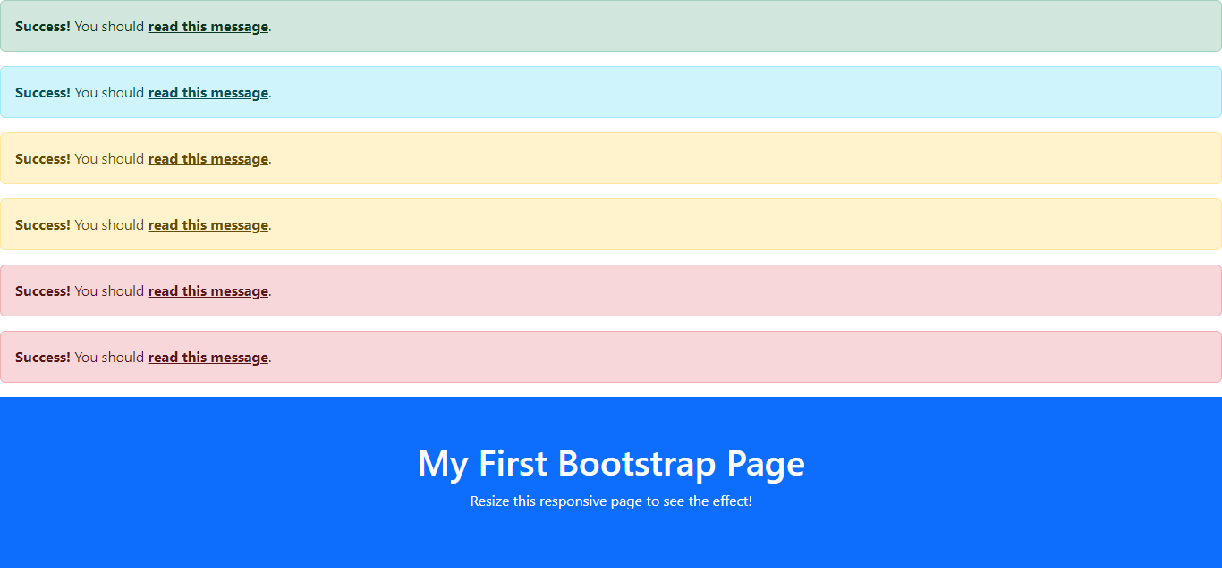

# TASK 2:

<!DOCTYPE html>

<html lang="en">

<head>

  <title>Bootstrap Page</title>

  <meta charset="utf-8">

  <meta name="viewport" content="width=device-width, initial-scale=1">

  <link href="https://cdn.jsdelivr.net/npm/bootstrap@5.3.2/dist/css/bootstrap.min.css" rel="stylesheet">

  <script src="https://cdn.jsdelivr.net/npm/bootstrap@5.3.2/dist/js/bootstrap.bundle.min.js"></script>

</head>

<body>

<div class="container-fluid p-5 bg-primary text-white text-center">

  <h1>My First Bootstrap Page</h1>

  <p>Resize this responsive page to see the effect!</p>

</div>

<button type="button" class="btn" onclick="handleButtonClick(this)">Basic</button>

<button type="button" class="btn btn-light" onclick="handleButtonClick(this)">Default</button>

<button type="button" class="btn btn-primary" onclick="handleButtonClick(this)">Primary</button>

<button type="button" class="btn btn-success" onclick="handleButtonClick(this)">Success</button>

<button type="button" class="btn btn-info" onclick="handleButtonClick(this)">Info</button>

<button type="button" class="btn btn-warning" onclick="handleButtonClick(this)">Warning</button>

<button type="button" class="btn btn-danger" onclick="handleButtonClick(this)">Danger</button>

<button type="button" class="btn btn-link" onclick="handleButtonClick(this)">Link</button>

<script>

  function handleButtonClick(button) {

    var buttonText = button.innerText;

    alert("Button clicked: " + buttonText);

  }

</script>

</body>

</html>

# OUTPUT:

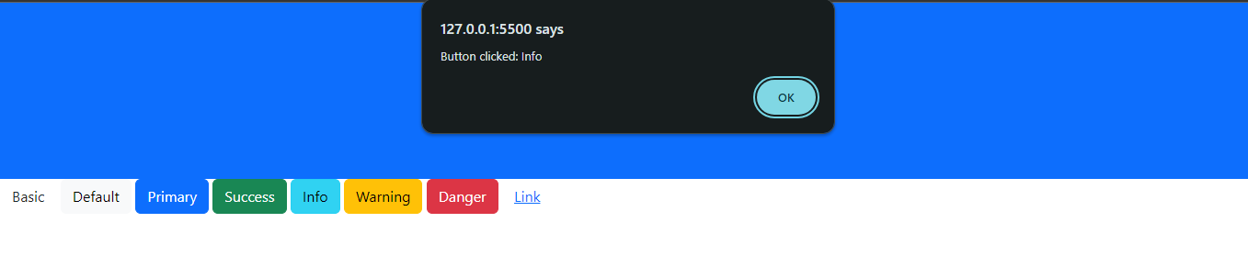

# TASK 3:

<!DOCTYPE html>

<html lang="en">

<head>

  <title>Bootstrap Page</title>

  <meta charset="utf-8">

  <meta name="viewport" content="width=device-width, initial-scale=1">

  <link href="https://cdn.jsdelivr.net/npm/bootstrap@5.3.2/dist/css/bootstrap.min.css" rel="stylesheet">

  <script src="https://cdn.jsdelivr.net/npm/bootstrap@5.3.2/dist/js/bootstrap.bundle.min.js"></script>

</head>

<body>

  <form id="calculatorForm">

    <label for="num1">Enter Number 1: </label>

    <input type="number" id="num1" required><br>

    <label for="num2">Enter Number 2: </label>

    <input type="number" id="num2" required><br>

    <button type="button" onclick="calculate()">Calculate</button>

    <h3>Results:</h3>

    <p id="addResult">Addition: </p>

    <p id="subtractResult">Subtraction: </p>

    <p id="multiplyResult">Multiplication: </p>

    <p id="divideResult">Division: </p>

  </form>

  <script>

    function calculate() {

      // Get values from input fields

      var num1 = parseFloat(document.getElementById("num1").value);

      var num2 = parseFloat(document.getElementById("num2").value);

      // Perform calculations

      var addResult = num1 + num2;

      var subtractResult = num1 - num2;

      var multiplyResult = num1 * num2;

      var divideResult = (num2 !== 0) ? num1 / num2 : "Cannot divide by zero";

      // Display results

      document.getElementById("addResult").innerText = "Addition: " + addResult;

      document.getElementById("subtractResult").innerText = "Subtraction: " + subtractResult;

      document.getElementById("multiplyResult").innerText = "Multiplication: " + multiplyResult;

      document.getElementById("divideResult").innerText = "Division: " + divideResult;

    }

  </script>

</body>

</html>

# OUTPUT:

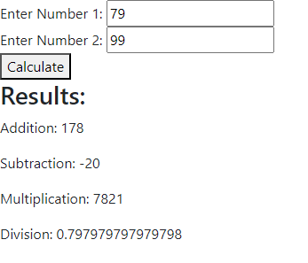

# 

# TASK 4:

<!DOCTYPE html>

<html lang="en">

<head>

  <title>Bootstrap Page</title>

  <meta charset="utf-8">

  <meta name="viewport" content="width=device-width, initial-scale=1">

  <link href="https://cdn.jsdelivr.net/npm/bootstrap@5.3.2/dist/css/bootstrap.min.css" rel="stylesheet">

  <script src="https://cdn.jsdelivr.net/npm/bootstrap@5.3.2/dist/js/bootstrap.bundle.min.js"></script>

</head>

<body>

  <label for="monthInput">Enter the name of the month (e.g., Jan, Feb): </label>

  <input type="text" id="monthInput">

  <button onclick="getDaysInMonth()">Submit</button>

  <div id="result"></div>

  <script>

    function getDaysInMonth() {

      // Get user input from the input field

      var monthInput = document.getElementById("monthInput").value.toUpperCase();

      // Define months and their corresponding days

      var months = {

        JAN: 31,

        FEB: 28,

        MAR: 31,

        APR: 30,

        MAY: 31,

        JUN: 30,

        JUL: 31,

        AUG: 31,

        SEP: 30,

        OCT: 31,

        NOV: 30,

        DEC: 31

      };

      // Check if the entered month is valid

      if (months.hasOwnProperty(monthInput)) {

        // Display the total number of days in red color

        var days = months[monthInput];

        document.getElementById("result").innerHTML = `<p style="color: red;">Total days in ${monthInput}: ${days}</p>`;

      } else {

        // Display an error message if the month is not recognized

        document.getElementById("result").innerHTML = '<p style="color: red;">Invalid month name. Please enter a valid month abbreviation.</p>';

      }

    }

  </script>

</body>

</html>

# OUTPUT:

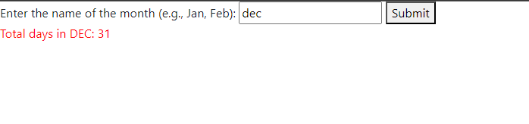

# TASK 5:

<!DOCTYPE html>

<html lang="en">

<head>

  <title>Bootstrap Page</title>

  <meta charset="utf-8">

  <meta name="viewport" content="width=device-width, initial-scale=1">

  <link href="https://cdn.jsdelivr.net/npm/bootstrap@5.3.2/dist/css/bootstrap.min.css" rel="stylesheet">

  <script src="https://cdn.jsdelivr.net/npm/bootstrap@5.3.2/dist/js/bootstrap.bundle.min.js"></script>

</head>

<body>

  <script>

    // Prompt user for a number

    var userNumber = prompt("Enter a number:");

    // Print the multiplication table

    document.write(`<h2>Multiplication Table for ${userNumber}</h2>`);

    for (let i = 1; i <= 10; i++) {

      var result = userNumber * i;

      document.write(`${userNumber} x ${i} = ${result}<br>`);

    }

  </script>

</body>

</html>

# OUTPUT:

